1. Go to AWS SSO console

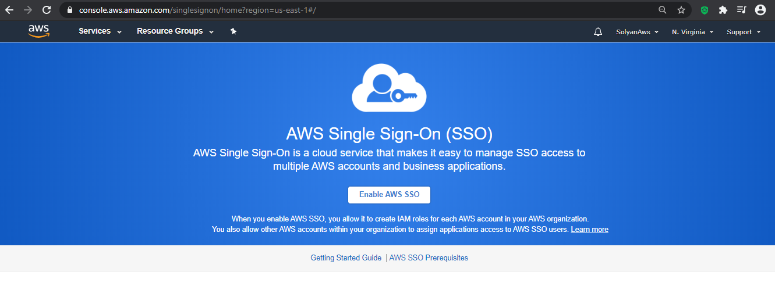

1. Enable AWS SSO

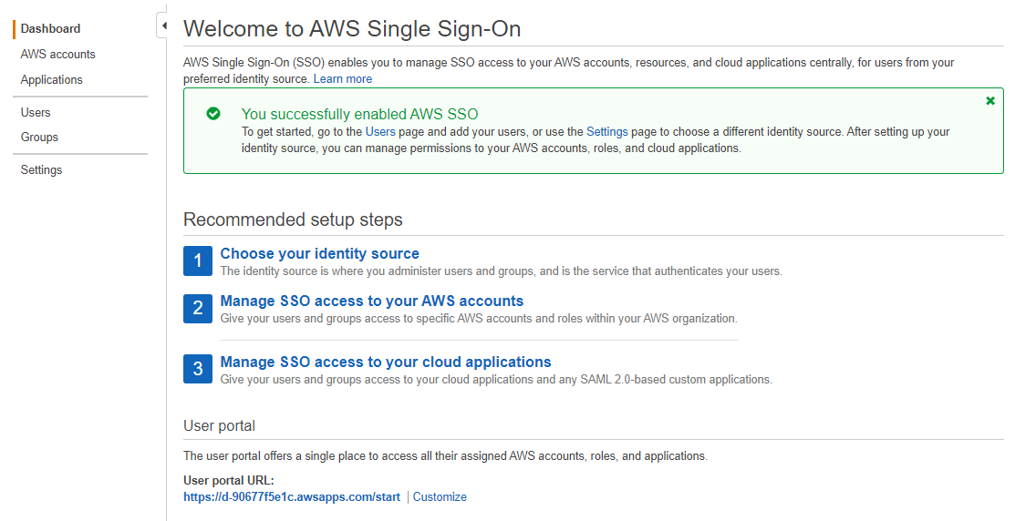

1. Add user with some permission

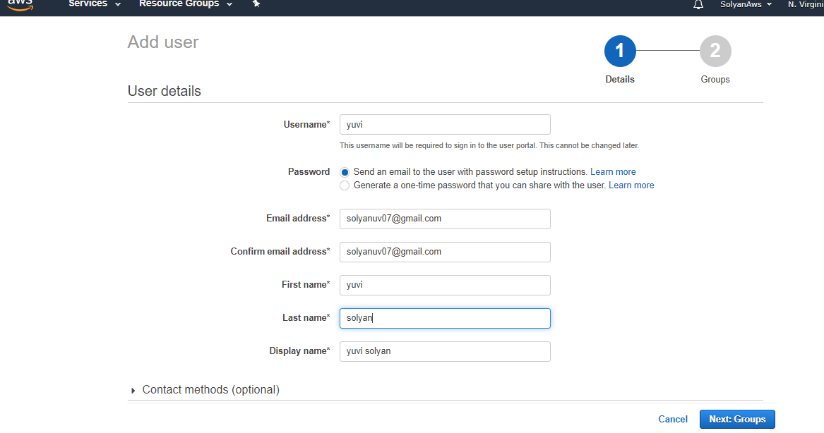

1. Add user into a group

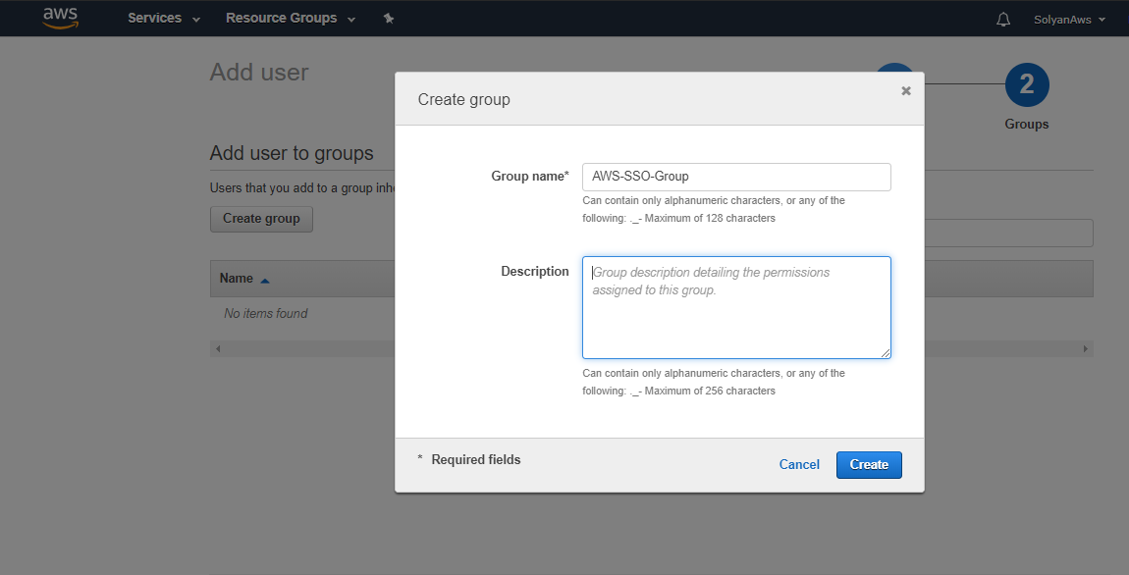

1. Add an application on which you want to apply AWS SSO

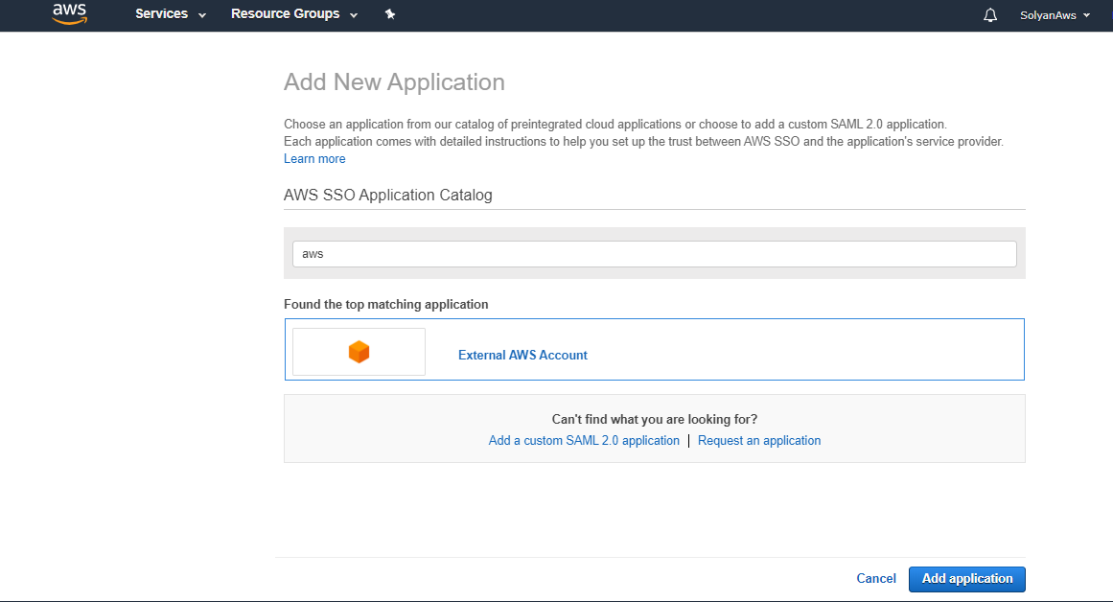

1. Configure this application For SAML

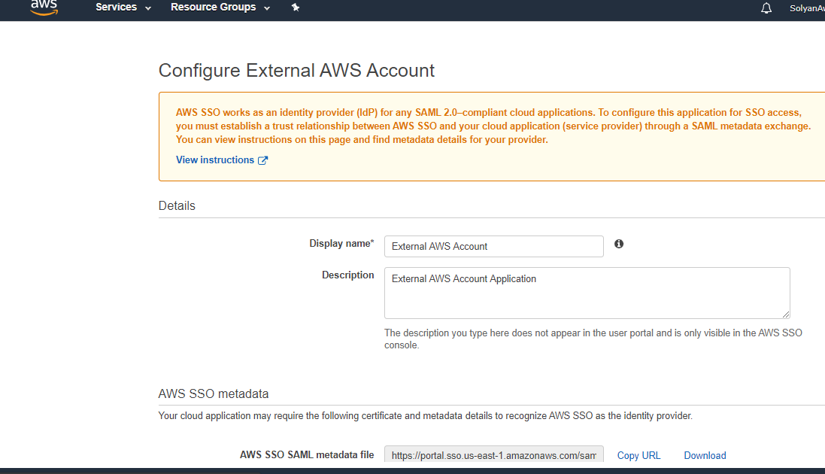

1. Now assign the users with this added application

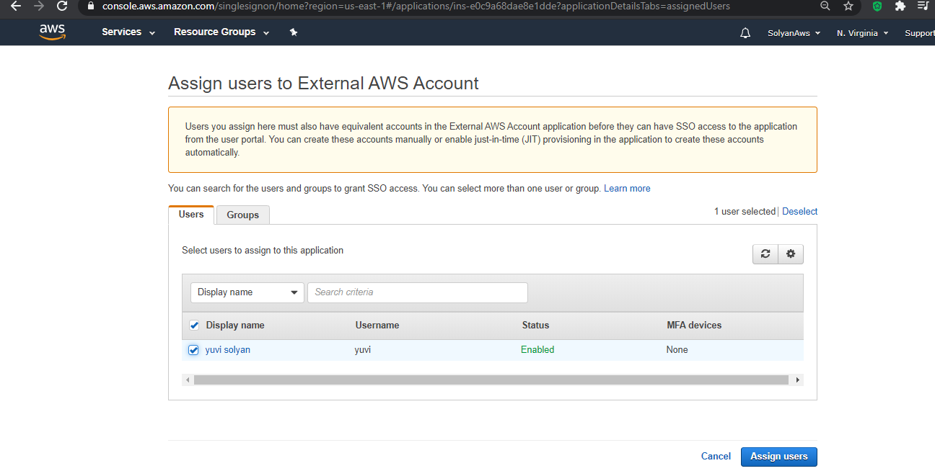

1. Set the permission for this users

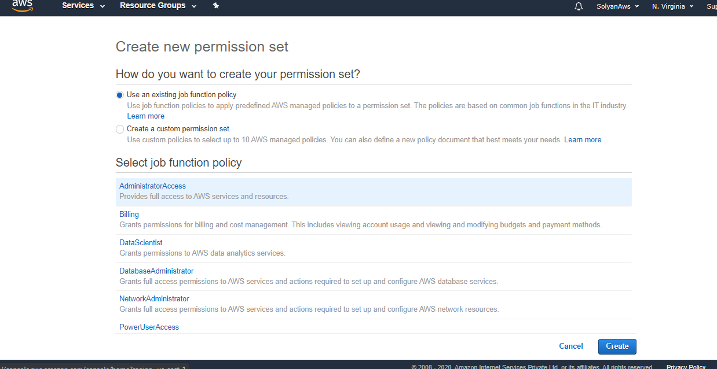

1. Now You will get an invitation on the given email id of added user and accept the invitation to performing the desired operations on AWS console using these creds

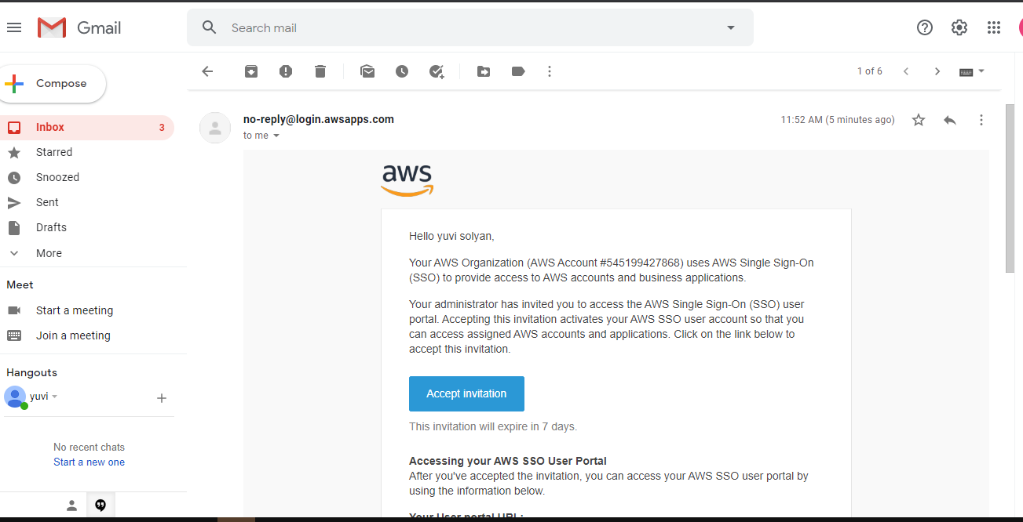

1. After accepting the invitation you will get the pop up like this

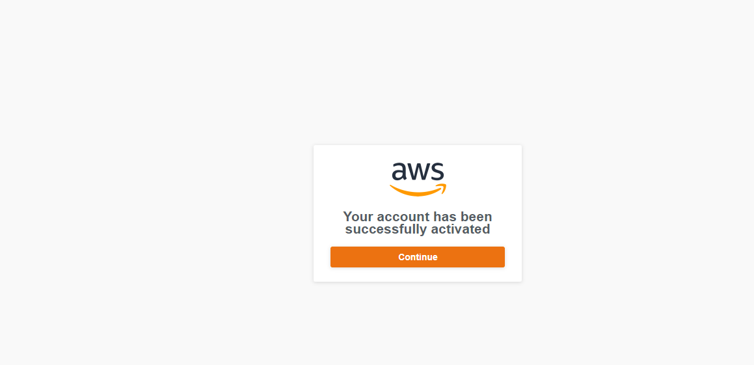

1. Now You are redirected to AWS account console

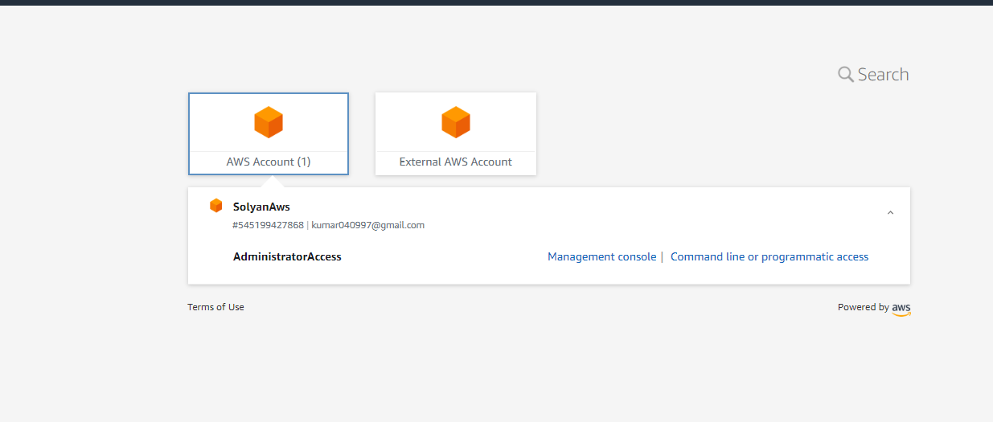

1. After login with user’s cred you will see the usrname arn like this

